**Alex Barbero**

4/20/2021

**Planning Stages CISC 3160**

2 Languages Ruby and Rust

I will be using the three sorting algorithms quicksort, mergesort, insertion sort

**Pseudo code**

Quicksort(A,p,r){

If p < r

q= Partition(A,p,r)

Quicksort(A,p,q-1)

Quicksort(A,q+1,r)

}

Partition(A,p,r){

X = A[r]

I = p - 1

For j = p to r - 1

if A[j] <= X

I = i + 1

Swap A[i] with A[j]

Swap A[i+1] with A[r]

Return i + 1

}

----------------------------------------------------------

Merge-Sort(A, p, r){

If p < r

q= floor(p+r/2)

Merge-Sort(A,p,q)

Merge-Sort(A, q+1, r)

Merge(A,p,q,r)

}

----------------------------------------------------------

Insertion-Sort(A){

For j=2 to A.length

key=A[j]

I = j - 1

While i> 0 and A[i] > key

A[i+1] = A[i]

i= i - 1

A[i+1] = key

}

**Language Reference Guide**

**Ruby**

**https://alhassy.github.io/RubyCheatSheet/CheatSheet.pdf**

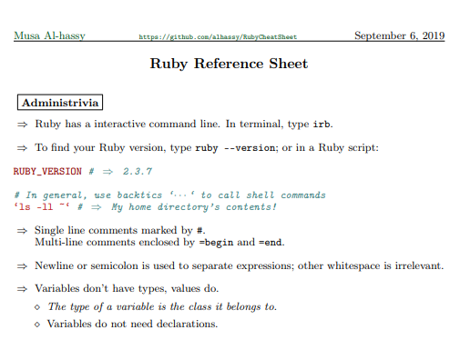

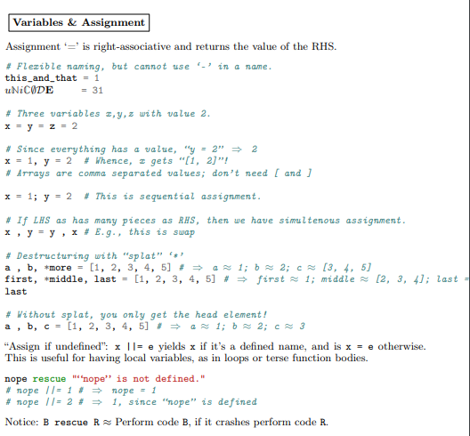

def used to define functions, class for classes

p is used to print

end is used to end a loop or function, Break is used to break out of a loop

**Rust**

<https://cheats.rs/rust_cheat_sheet.pdf>

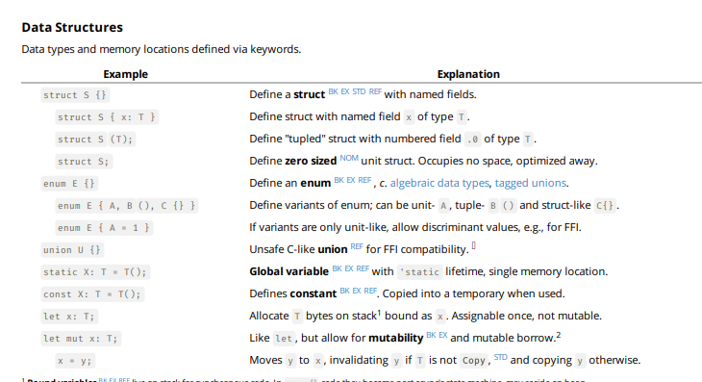

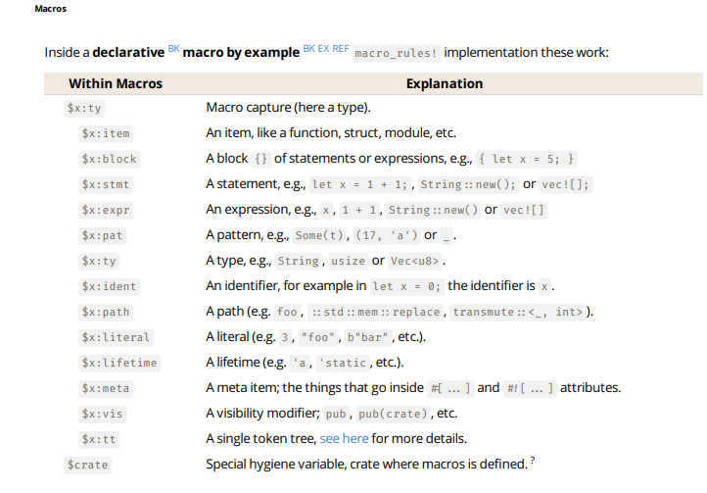

println! To print

fn is used to declare functions

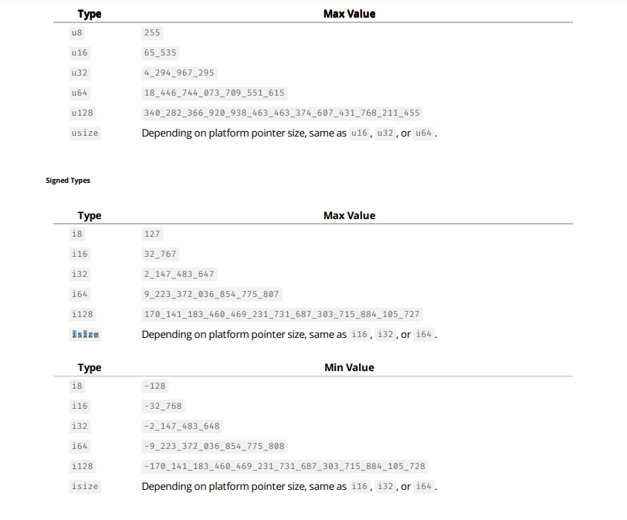

**Sources:**

Youtube - edutechional very helpful videos with learning ruby and implementing algorithms

<https://www.youtube.com/user/edutechional/videos?view=0&sort=da&flow=grid>

HappyChuckProgramming - helpful videos for implementing algorithms in rust

<https://www.youtube.com/channel/UChjK0Ht3LhMOMpNE_WFa82A>

<https://www.tutorialspoint.com/ruby/index.htm> - good resource to get started with ruby

<https://doc.rust-lang.org/book/title-page.html> - rust book explaining to get started and learn rust

<https://doc.rust-lang.org/stable/std/>

<https://www.rust-lang.org/>

https://www.ruby-lang.org/en/